AI STUDYBUDDY
PHASE-WISE PROJECT DOCUMENT
AI-Powered Study Assistance and Recommendation API
TEAM MEMBERS
Diviia Srrii D
Kaviya K
Jayachithra M
Velankanni P
PHASE 1 – PROJECT SETUP
1.1 Project Creation
The AI StudyBuddy project was created as a backend application for study-related functionality. The project was opened in Visual Studio Code and the required backend files were organized in the project folder.
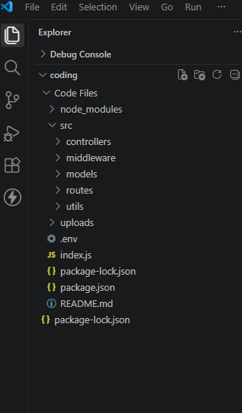
1.2 Project Configuration
The backend project was configured using Node.js and Express.js. The required project files and packages were prepared before implementing the API functionality.
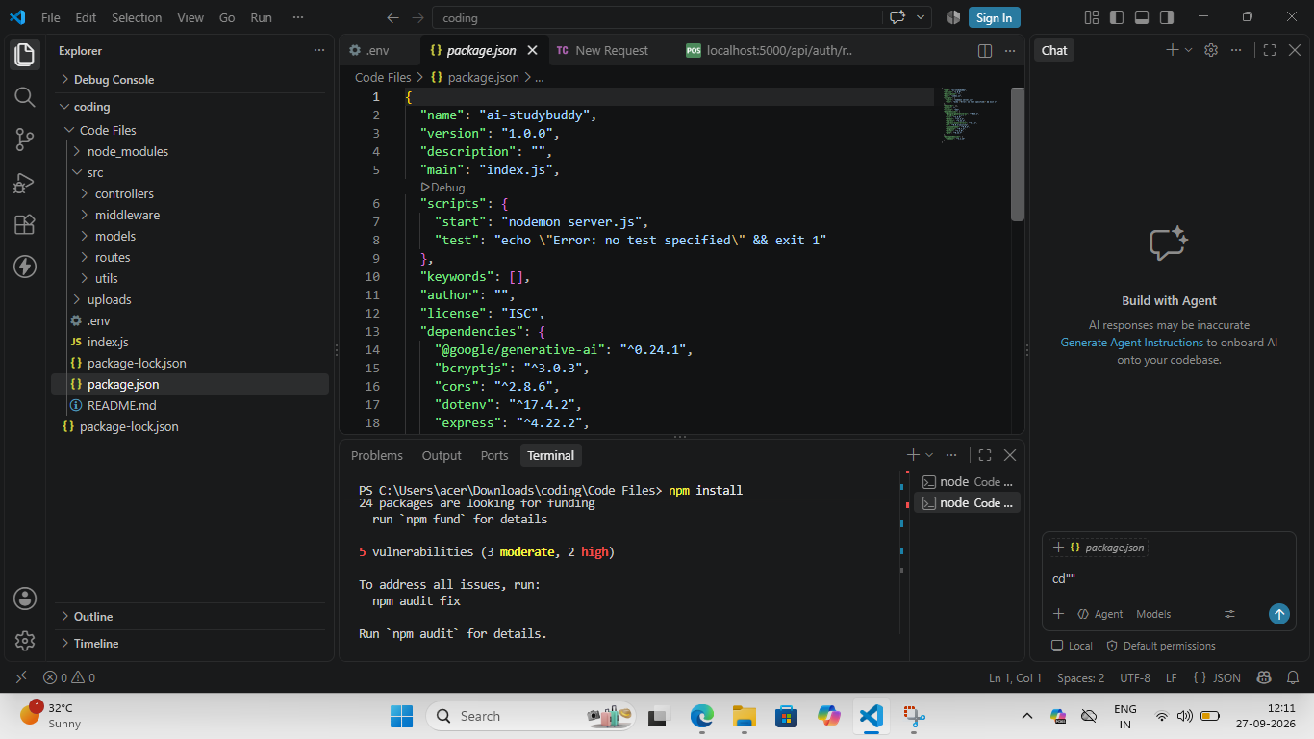
1.3 Server Setup
The backend server was configured to run locally. After starting the server, the API endpoints could be tested using Thunder Client.
PHASE 2 – BACKEND DEVELOPMENT
2.1 Backend File Development
The backend functionality was implemented by creating and modifying the required JavaScript files. The code was organized according to the functions performed by the AI StudyBuddy application.
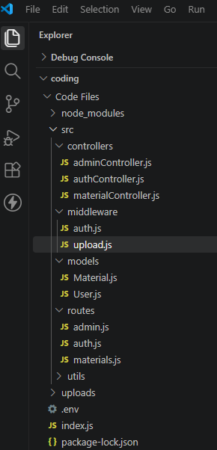
2.2 API Route Implementation
REST API routes were created to receive requests from the API testing tool. The routes process the input and return the required response in JSON format.
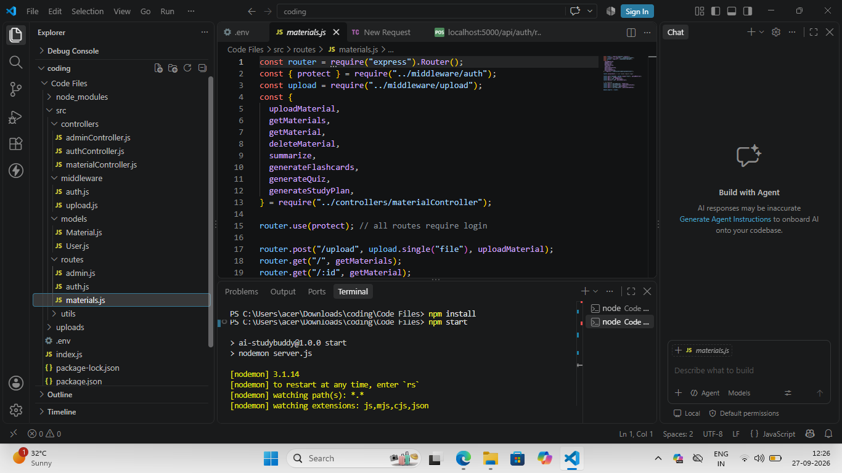
2.3 Request and Response Handling
The backend receives request data, validates the required information, processes the request, and sends a JSON response. Successful and unsuccessful requests are handled separately.
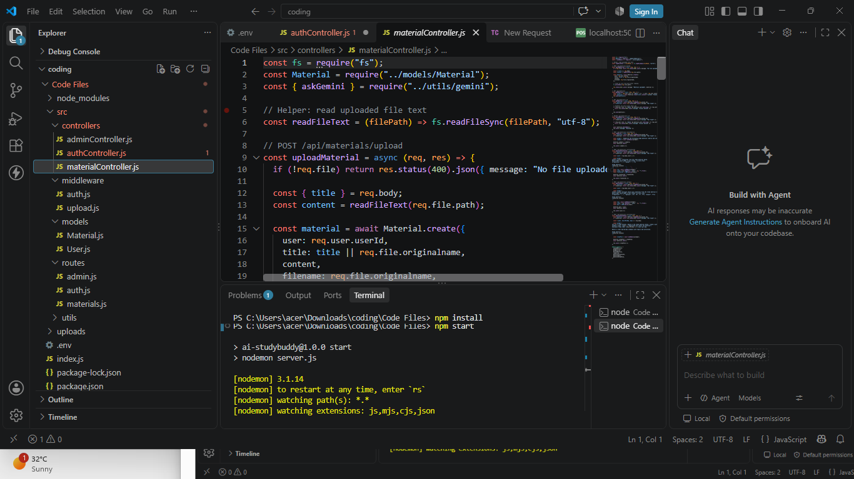
PHASE 3 – AI STUDY RECOMMENDATION IMPLEMENTATION
3.1 AI Feature
The AI StudyBuddy project includes an AI-powered study assistance feature. The feature generates study-related recommendations based on information provided by the user.
3.2 Input Data
The AI StudyBuddy API accepts the required study information from the user. The information is sent to the backend as a JSON request.
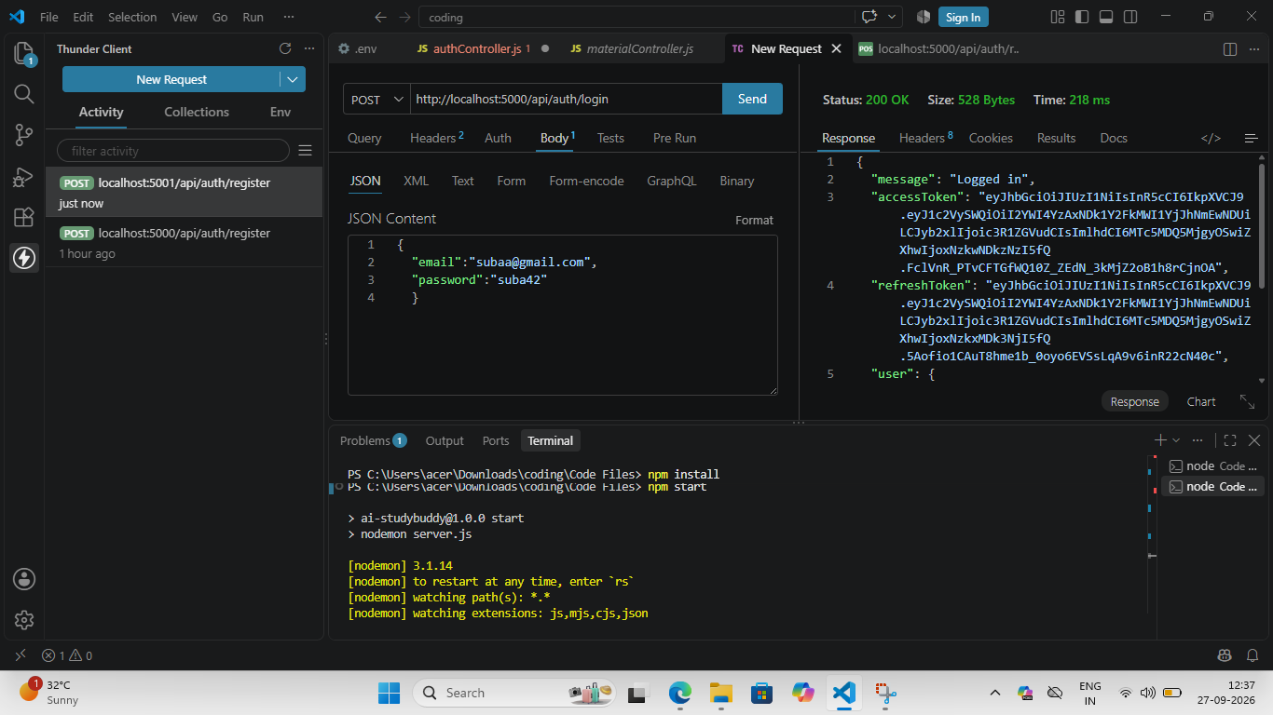
3.3 AI Response
After processing the request, the AI functionality returns a study-related recommendation or response. The response is displayed as JSON through the API.
[ AI RESPONSE SCREENSHOT NOT PROVIDED — INSERT ACTUAL AI RESPONSE SCREENSHOT HERE ]
PHASE 4 – API TESTING
4.1 Thunder Client Testing
Thunder Client was used to test the implemented API endpoints. Each API was tested by sending the required request and checking the response returned by the backend.
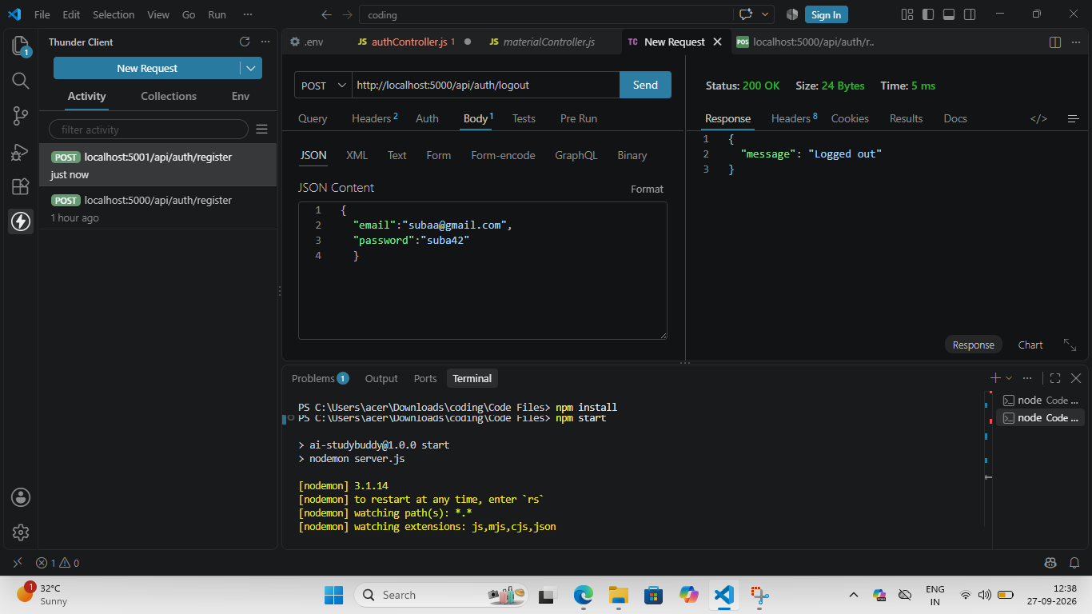
4.2 Successful API Response
The API testing verified that the backend accepts valid input and returns the expected response.
4.3 Error Testing
Invalid or incomplete input was tested to verify that the backend returns an appropriate error response.
[ ERROR RESPONSE SCREENSHOT NOT PROVIDED — INSERT ACTUAL ERROR RESPONSE SCREENSHOT HERE ]
PHASE 5 – PROJECT EXECUTION AND RESULT
5.1 Complete Project Execution
The completed AI StudyBuddy backend was executed locally and the implemented API functionality was tested. The API requests and responses were verified using Thunder Client.
5.2 Final Output
The final output demonstrates that the implemented backend can receive study-related information, process the request, and return the required response through the API.
5.3 Result
The AI StudyBuddy project was completed with backend API functionality and an AI-powered study assistance feature. The implemented APIs were tested using Thunder Client and the responses were verified.
AI STUDYBUDDY PROJECT SCREENSHOT CHECKLIST
- Project folder in VS Code
- package.json / project configuration
- Server running in terminal
- Backend files in VS Code
- API route code
- Controller / API handling code
- AI StudyBuddy / AI recommendation code
- Thunder Client request body
- Thunder Client AI response
- Thunder Client API testing
- Successful API response
- Error response
- Final project execution
- Final successful output
Note: Insert your own screenshots in the marked places. Use only screenshots that belong to your actual AI StudyBuddy project.

